Academic Year 2023/24
COURSEWORK ASSIGNMENT

Module Code: BNM817

Module Name: Effective Management Consultancy

Module Leader: Dr Amrik Singh

Coursework Title:

Client Consulting Assignment

Task Details/Description:

Background
Management consultancy involves working with clients to solve complex problems. Often these problems present themselves as complex and ambiguous with multiple stakeholders. This assignment will involve you in applying the concepts and tools and techniques of consulting to a problem situation of your choice in order to develop recommendations for improvement.

Problem selection
For the assignment, you should choose a problem situation to be the focus of your analysis. This problem can be a social or an organisational problem. It can be a problem situation that you are interested in exploring, or it could be a problem in an organisation you are familiar with. The important thing is that it meets certain criteria. The problem should be complex (ie it should have several stakeholders) and it should be ambiguous (ie it should have no obvious solution).

You should submit a brief one page description of your problem using the one page template provided (BNM817 one page project approval form). The module tutors will give you feedback, advice and guidance in selecting your problem situation. In formulating your problem, you should identify a notional client. This could be a real client or it could be a stakeholder who would be interested in the findings of your study.

Assignment
Using the concepts, tools and techniques taught in the course, develop an analysis of the problem situation and use this analysis to develop a set of recommendations to improve the problem situation. Guidance on the development of this coursework will be given in the weekly tutorials.

Module Learning Outcomes Assessed:

- Appraise a complex situation using problem structuring.
- Prepare a soft systems analysis of a complex, ambiguous problem situation.
- Recommend the most appropriate consulting approach for a particular organisational challenge.

Presentation Requirements:

Word Count: 3,000 maximum

Font Size: 12

Line Spacing: 1

Submission Date & Time:

To be confirmed

Assessment Weighting for the Module:

100%

Assessment Criteria

Introduction
For this assignment, we will be making use of the Soft System Methodology (SSM) as an overall framework for exploring a complex, ambiguous client problem (see Figure 1 below). In following this approach, the following marking schema will be used.
Part 1 - Rich Picture – Stage 2 of the Methodology (20%).
Task : Prepare a Rich Picture of the client’s problem situation.
Evaluation : The Rich Picture should be comprehensive, broadly follow guidelines and be useful. It should use symbols and pictures with a limited amount of words that mostly only relate to the detail. It should clearly show the relationships between issues. It should be easily understood and absorbed at a glance, rather than require reading.
Part 2 - SSM Analysis – Stages 3 and 4 of the Methodology (50%)

Task : Conduct an SSM analysis of the problem situation.
Identify the key stakeholders in the problem situation. Select two stakeholders you consider to be important in this situation. Ideally with conflicting ideas or relationships between the two stakeholders. Justify and explain your selection. For each of these stakeholders, develop:

- PQR statement
- Expanded as a CATWOE
- Simplified to a root definition statement

For each of the root definitions, prepare:

- A conceptual model
- Include 3Es

Task: Extend the analysis of the situation. This should contain any additional modelling, thinking or insights relevant to your understanding the situation.

Select two further stakeholders that you consider as important in the situation. Again, with conflicting ideas or relationships. Develop the same deliverables as above.

Evaluation : Evaluation: The SSM Analysis will be marked on technical accuracy of the modelling: PQR, CATWOE, RD, 3 E’s and Conceptual Model and the coherence between these.

Part 3 – Complementary Analysis (10%)

Task: Complementary Analysis. Carry out additional analysis as you see fit outside of the scope of SSM. Here you can use techniques and tools that you have come across outside of the module in your other studies and reading.

Evaluation : The complementary analysis will be evaluated according to the appropriateness of the additional tool(s) chosen and the insights achieved by their application.

Part 4 - Recommendations - Stages 5 and 6 of the Methodology (20%)

Task : Based on your analysis, compare the desired situation with the current state. Use this to generate potential changes to the system. Evaluate these changes and make recommendations to our client. Bear in mind the difference between ‘accommodation’ and ‘consensus’ as described by Checkland (2006) on pages 54,55.

Evaluation : Recommendations should demonstrate that you appreciate the breadth of issues that you have uncovered in your analysis. In addition, you should examine how these desired changes can be brought about.

Figure 1
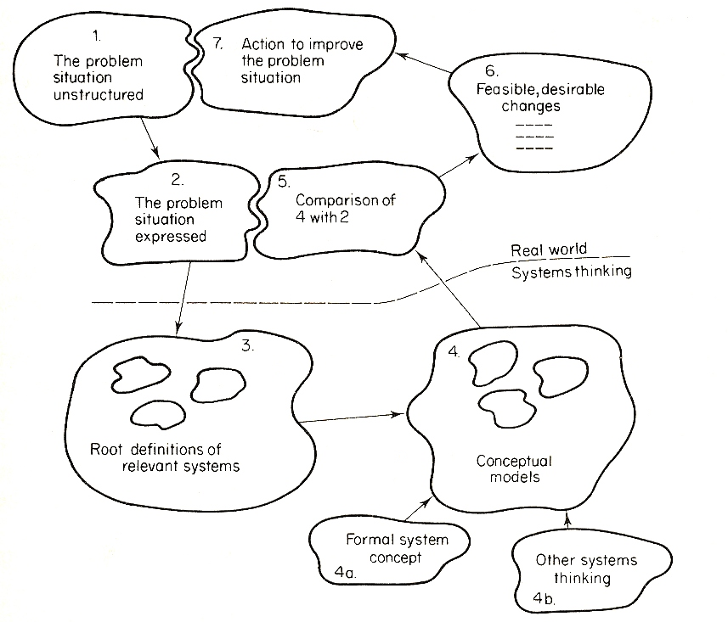

Ethical Requirements

Remember your responsibility to respect the confidentiality of any organisation and individuals that you choose as the focus of your study. Please make sure you are aware of the requirements of the Aston Business School Guidance on Ethics (see Aston University Website). If in doubt about any ethical aspect of the choice of your problem area, please contact the Module Leader.

Essential Reading for Coursework Task
(if in addition to reading provided in the module outline):

Please note that this is not intended as an exhaustive or definitive list of readings for this piece of coursework. Instead, the articles/chapters listed below should be viewed as core or essential readings that may act as a start point as you prepare to tackle this assignment:

1. From Checkland, P. & Poulter, J. (2006). ‘Learning for action : a short definitive account of soft systems methodology,and its use for practitioners, teachers and students’, Chichester: Wiley.
BNM817 Coursework Marking Guidance

 | 0 - 4 | 5-8 | 9-12 | 13-16 | 17-20
1. Rich picture  (Part 1 above)  Marks available: 20 | The rich picture is overly simplistic, it does not convey the problem situation. Most of the key characteristics are missing. | The rich picture conveys some of the complexity of the situation, but in order to understand it, further explanation is required. The rich picture contains some of the technical elements ie the stakeholders, the system boundary, the key issues and concerns, relationships between stakeholders and external agencies. However, there are several limitations in some of the characteristics. | The rich picture is largely standalone, but in order to understand it, further explanation is required. The rich picture contains most of the technical elements ie the stakeholders, the system boundary, the key issues and concerns, relationships between stakeholders and external agencies. However, there are limitations in some of the characteristics. | The rich picture is almost standalone, but in order to understand it, further explanation is required. The rich picture contains nearly all of the technical elements ie the stakeholders, the system boundary, the key issues and concerns, relationships between stakeholders and external agencies. However, there are limitations in a few of the characteristics. | The rich picture is standalone, it expresses the situation without the need for further explanation. The rich picture contains all the technical elements ie the stakeholders, the system boundary, the key issues and concerns, relationships between stakeholders and external agencies.
 | 0 - 10 | 11 - 20 | 21 - 30 | 31 - 40 | 41-50
2. SSM analysis of the problem situation  (Part 2 above)  Marks available: 50 | The selection of stakeholders is not justified. There are significant technical errors in the root definitions and conceptual models or they are missing. The 3Es are missing or are inappropriate. Overall the analysis of the situation is poor. | The selection of stakeholders is justified, but it is not clear why they have been chosen. The root definitions are defined, but there are significant errors. The conceptual models contain significant errors or are missing. The 3Es are not specific enough or are inappropriate. Overall the analysis of the situation could be improved. | The selection of stakeholders is justified, but there is some room for improvement in clarity. The root definitions are defined, but they could be improved technically. The conceptual models are overall accurate, but technical improvements are required. The 3Es are reasonable although could be improved in terms of appropriateness or be more specific to the situation. Overall the analysis demonstrates good understanding of the situation analysed | The selection of stakeholders is largely justified, but there is some room for improvement in clarity. The root definitions are well-defined, with minor technical inaccuracies. The conceptual models are accurate, with minor technical inaccuracies. The 3Es are appropriate although could be improved in terms of appropriateness or be more specific to the situation. Overall the analysis demonstrates a very good understanding of the situation analysed. | The selection of stakeholders are clearly justified. The purpose statements are clear, well-constructed and technically correct. The conceptual models are technically accurate. The 3Es are appropriate and specific to the situation. Overall the analysis demonstrates an excellent understanding of the situation analysed.
 | 0 - 2 | 3-4 | 5-6 | 7-8 | 9-10
3. Complementary analysis  (Part 3 above)  Marks available: 10 | The complementary analysis is missing or of poor quality. | The selection of additional tools is not really appropriate to the problem situation. The additional analysis does not provide real insights. | The selection of additional tools is appropriate to the problem situation. The additional analysis provides good insights. | The selection of additional tools is very appropriate to the problem situation. The additional analysis provides very good insights. | The selection of additional tools is innovative and appropriate to the problem situation. The additional analysis provides excellent insights.
 | 0 - 4 | 5-8 | 9-12 | 13-16 | 17-20
4. Recommendations (Part 4 above)  Marks available: 20 | The recommendations are unclear and are not supported by the analysis. | There are recommendations, but the link to the analysis could be clearer. The supporting evidence for the recommendations could be improved. | Recommendations are reasonably well supported by the analysis, but there is some room for improvement. Supporting evidence is present but could be strengthened. | There is a link between the analysis and the recommendations, but the clarity of this could be improved. The recommendations are convincing, but the justification could be improved a little. | There is a clear link between the analysis and the recommendations. The recommendations are convincing and well justified.

